**MINI PROJECT USING JAVAFX API AND JDBC**

**Project Video Demo** - <https://youtu.be/j1dnSrj_r_4>

**Project Source Code File -** <https://drive.google.com/folderview?id=14DXemkoI6FlzEdpzNbq5KGnKRqd3iYfC>

**Database File -** <https://drive.google.com/file/d/10L9g_pCFlvXiKEKcr03lNlZiYy5wvSGB/view?usp=drivesdkdrivesdk>

**AIM:-**

To implement the **Quiz Application Management System** using JavaFX API and Java Database Connectivity (JDBC).

**THEORY:-**

**Project Description:-**

The Quiz Application Management System brings to you a platform where teachers from various fields can connect with students belonging to different institutes.

A teacher creates the Quiz which is then open to all the students to answer.

As one starts the App the First Page will Appear. A user can either register as a teacher or a student. If the user has already registered, he/she may simply login to the App.

Once the Registration and Login procedure is complete, the teacher or the student will be directed to their respective Dashboard.

The various functionalities under each user are as follows:

1. Teacher

Once you login as a teacher the following features are included:

i) Create Quiz - Under this section the teacher can create a new quiz. Enter a few details about the quiz like the Quiz name, Number of questions, Description and the Difficulty level. Next enter the questions and the options and not forgetting the answer to the question! That is all you need to create a quiz.

ii) View Quiz - The View Quiz section allows the teacher to view all the quizzes created by them as well as the other teachers. It also allows them to edit the questions of the quizzes they created if they feel the need to do so. There is also a Delete Quiz option in this section which will let the teacher delete a quiz created by them if they wish to.

iii) View Results - You do not want to miss out on how the students perform! This section will let you view the results of all the students that attempted the quizzes created by you.

2. Student

Once you login as a student the following features are included:

i) View Quiz - The View Quiz section displays all the quizzes available on the App. The student can answer quizzes through this section. Once you click on a particular quiz of your choice, a quiz details like the rules, description and difficulty level will be displayed. You may proceed forward to answer the quiz and once done, you can submit the same. On submission, the quiz score will be displayed.

ii) View Results -The View Results section displays the results of all the quizzes that the student has answered. You can track your progress through this.

**Implementation:-**

**Quiz Application Management System**

The project begins with the start page. Click on the Start button to begin.

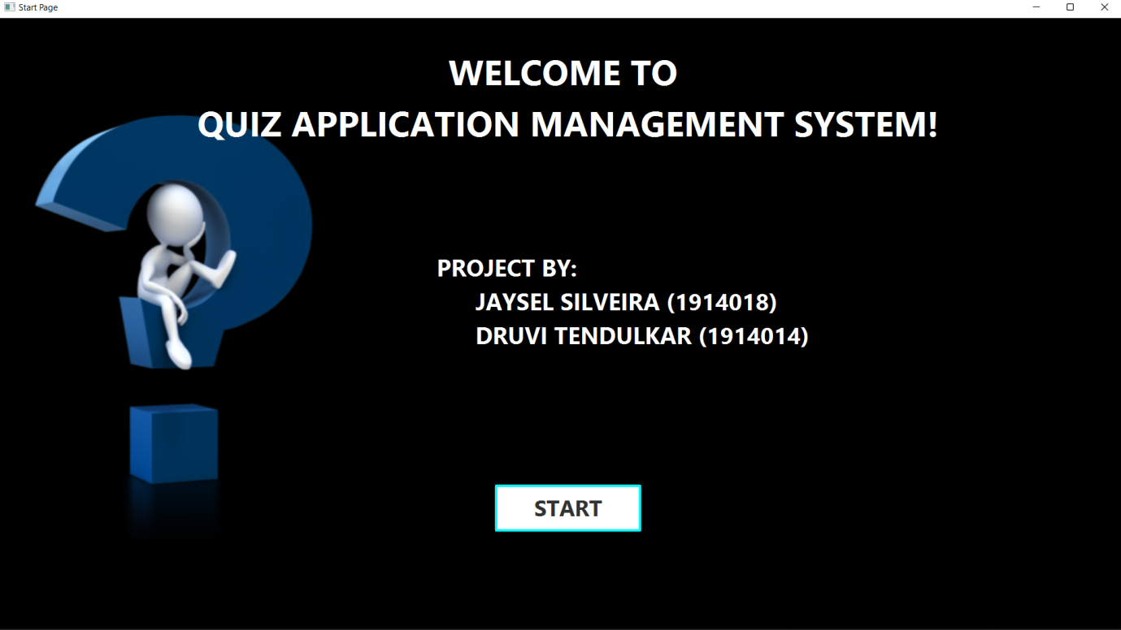

Next, you select the user i.e. a Teacher or A student. Let us first select the Teacher as a user.

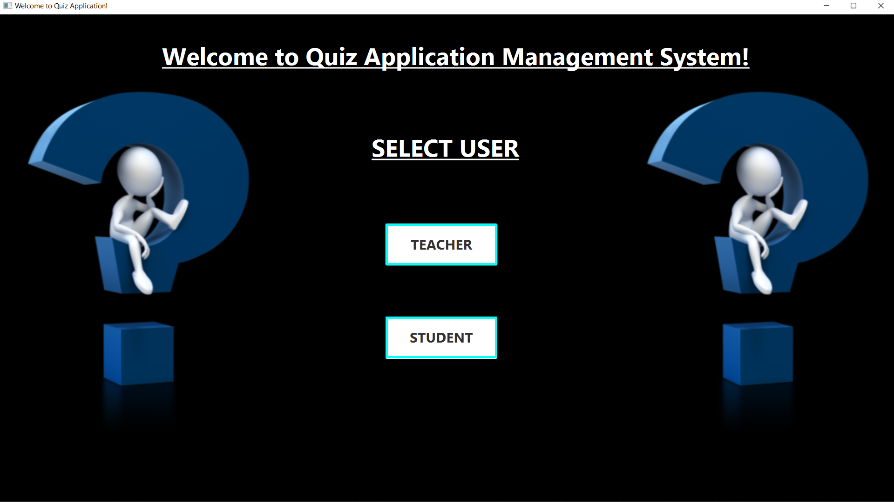

Next, choose whether you want to register or login. Let us first register.

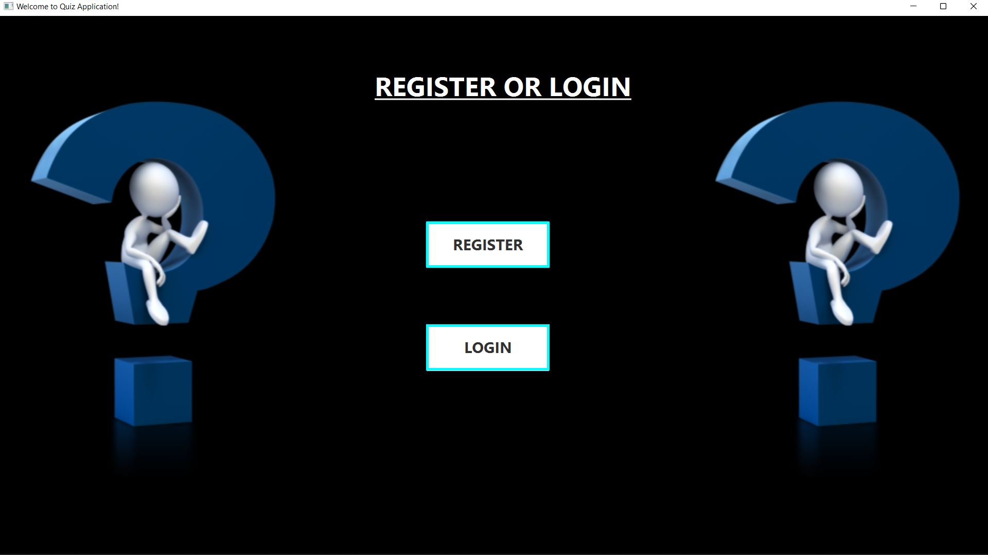

Below is how the registration page looks like. Fill in the details and click on submit. If you already have an account, then you may click on the login button.

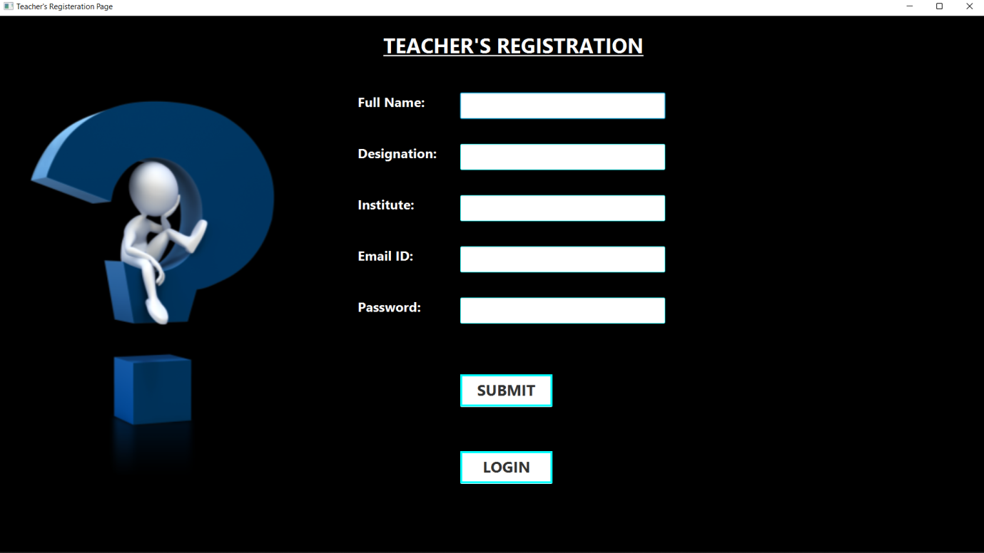

The teacher can reset the password if he/she wishes to by entering the details shown below.

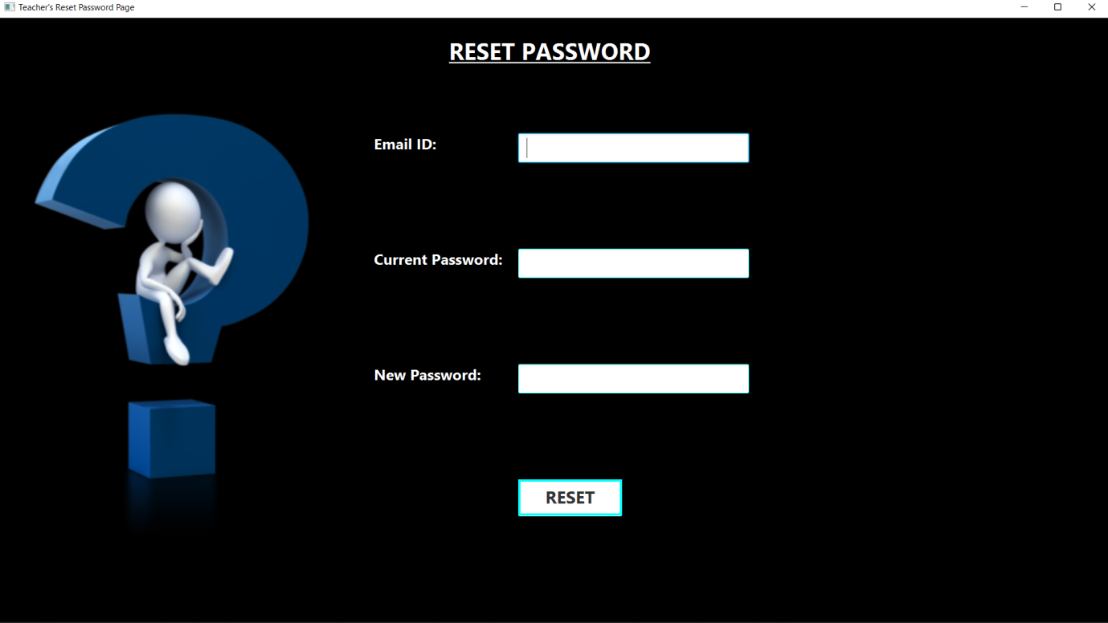

We proceed to the login page. Enter the details you used while registration. Make sure the Email ID and Password are correct.

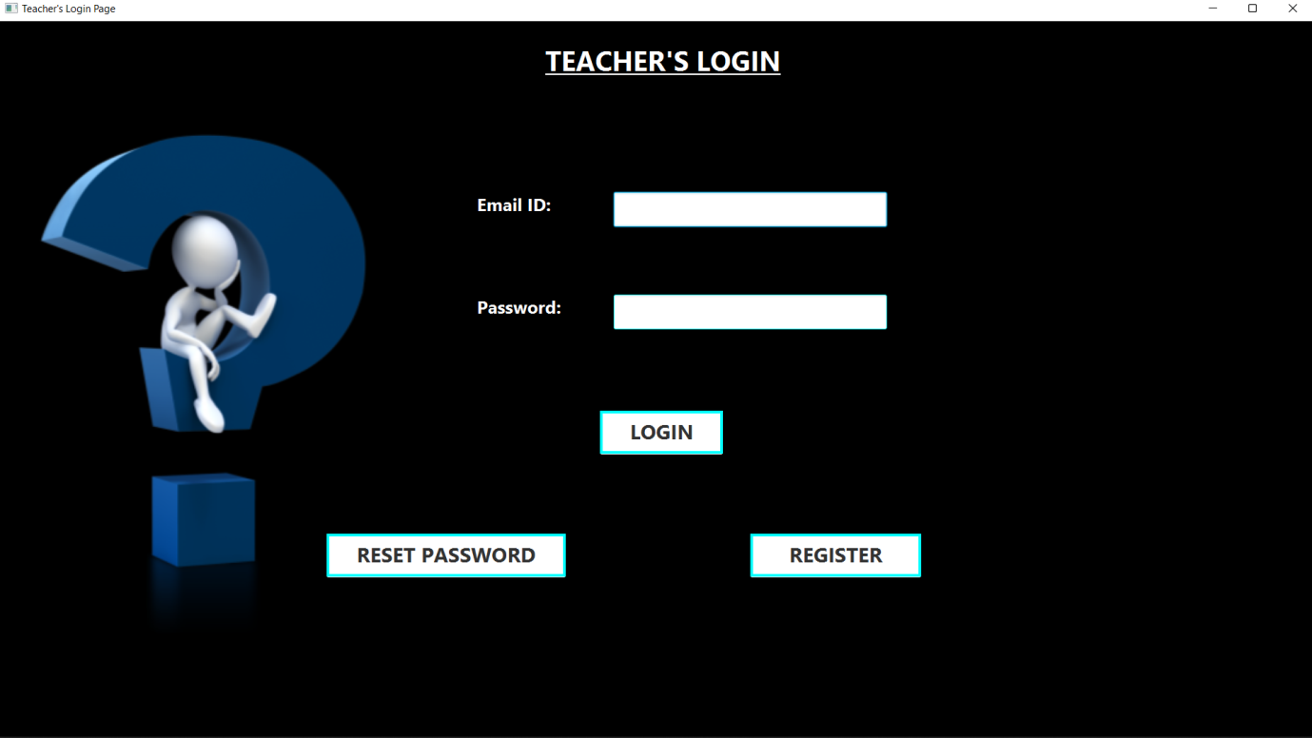

Once you login, the Teacher’s Dashboard opens. The image below shows the various features available. Let us have a look at each one of them.

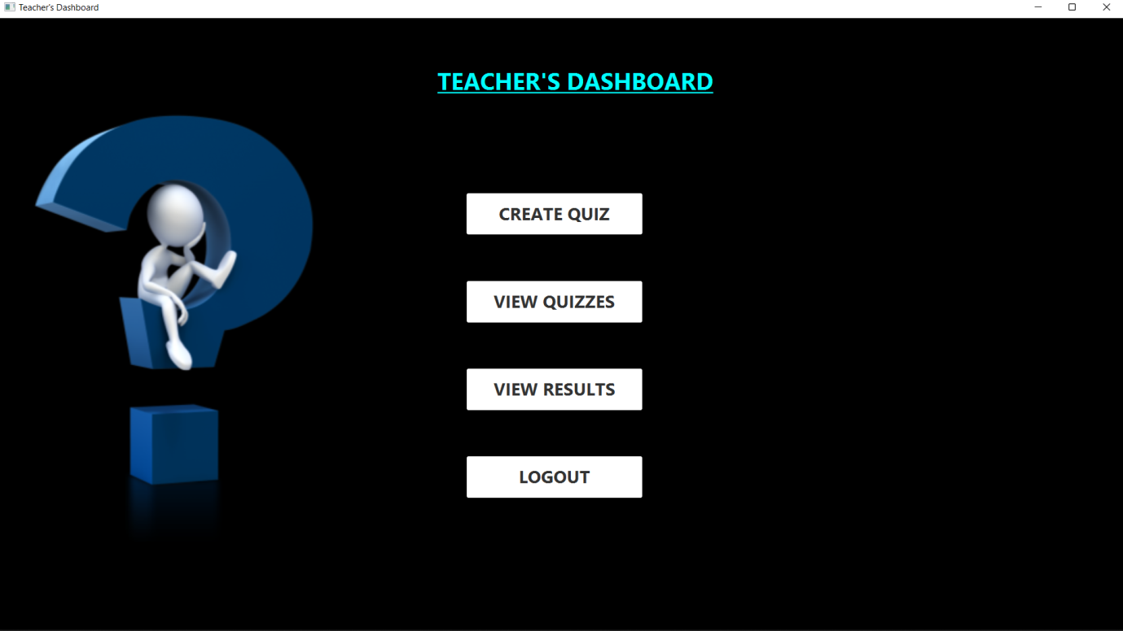

The create quiz section directs you to a form wherein you have to fill the quiz details as shown below.

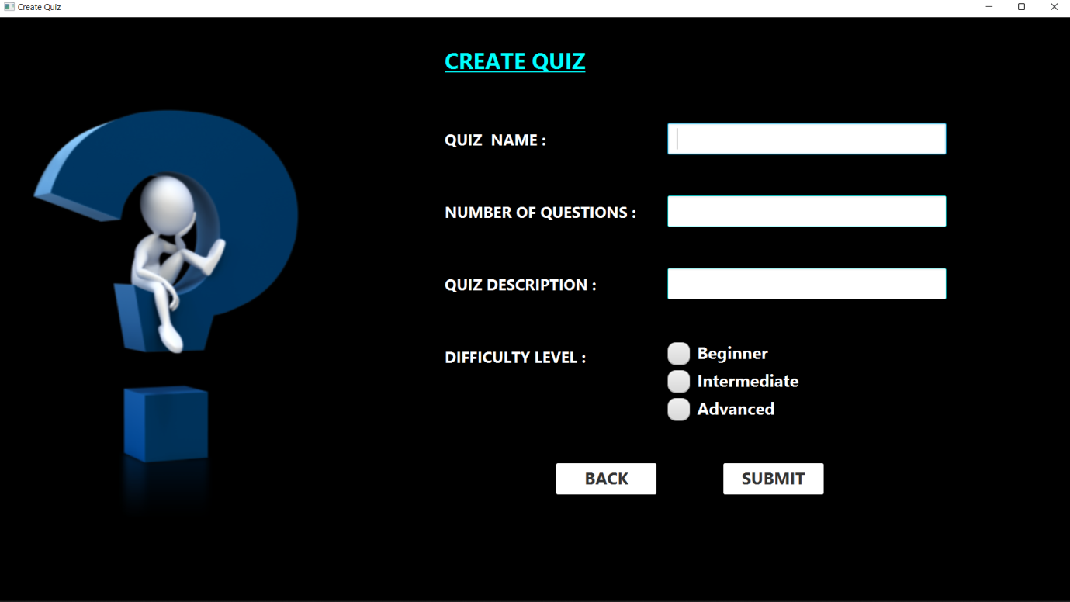

Next, based on the number of questions you have to enter the questions and the options along with the answer. Once you submit it, the quiz is created.

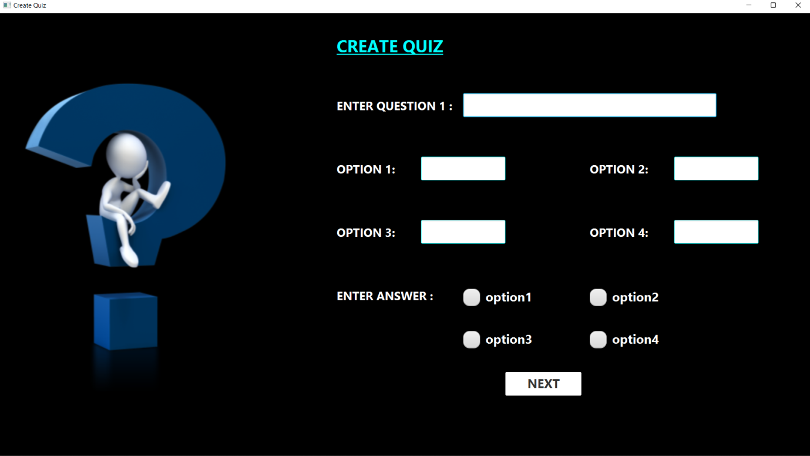

The view quiz section allows you to view all the quizzes available on the App as shown below.

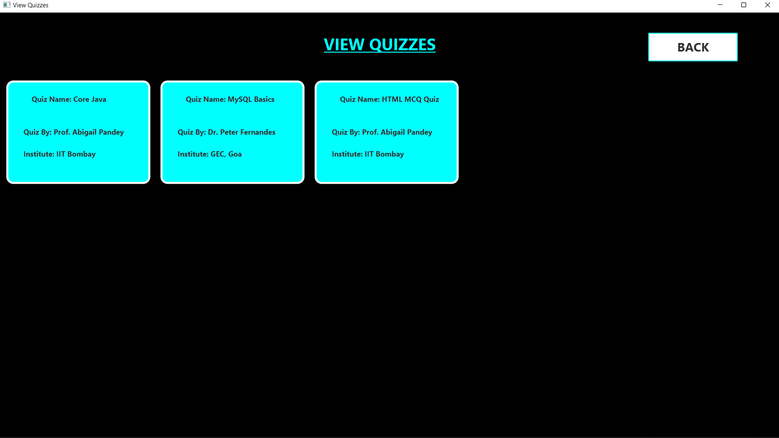

If you view a quiz created by another teacher you will be able to see the quiz details as follows.

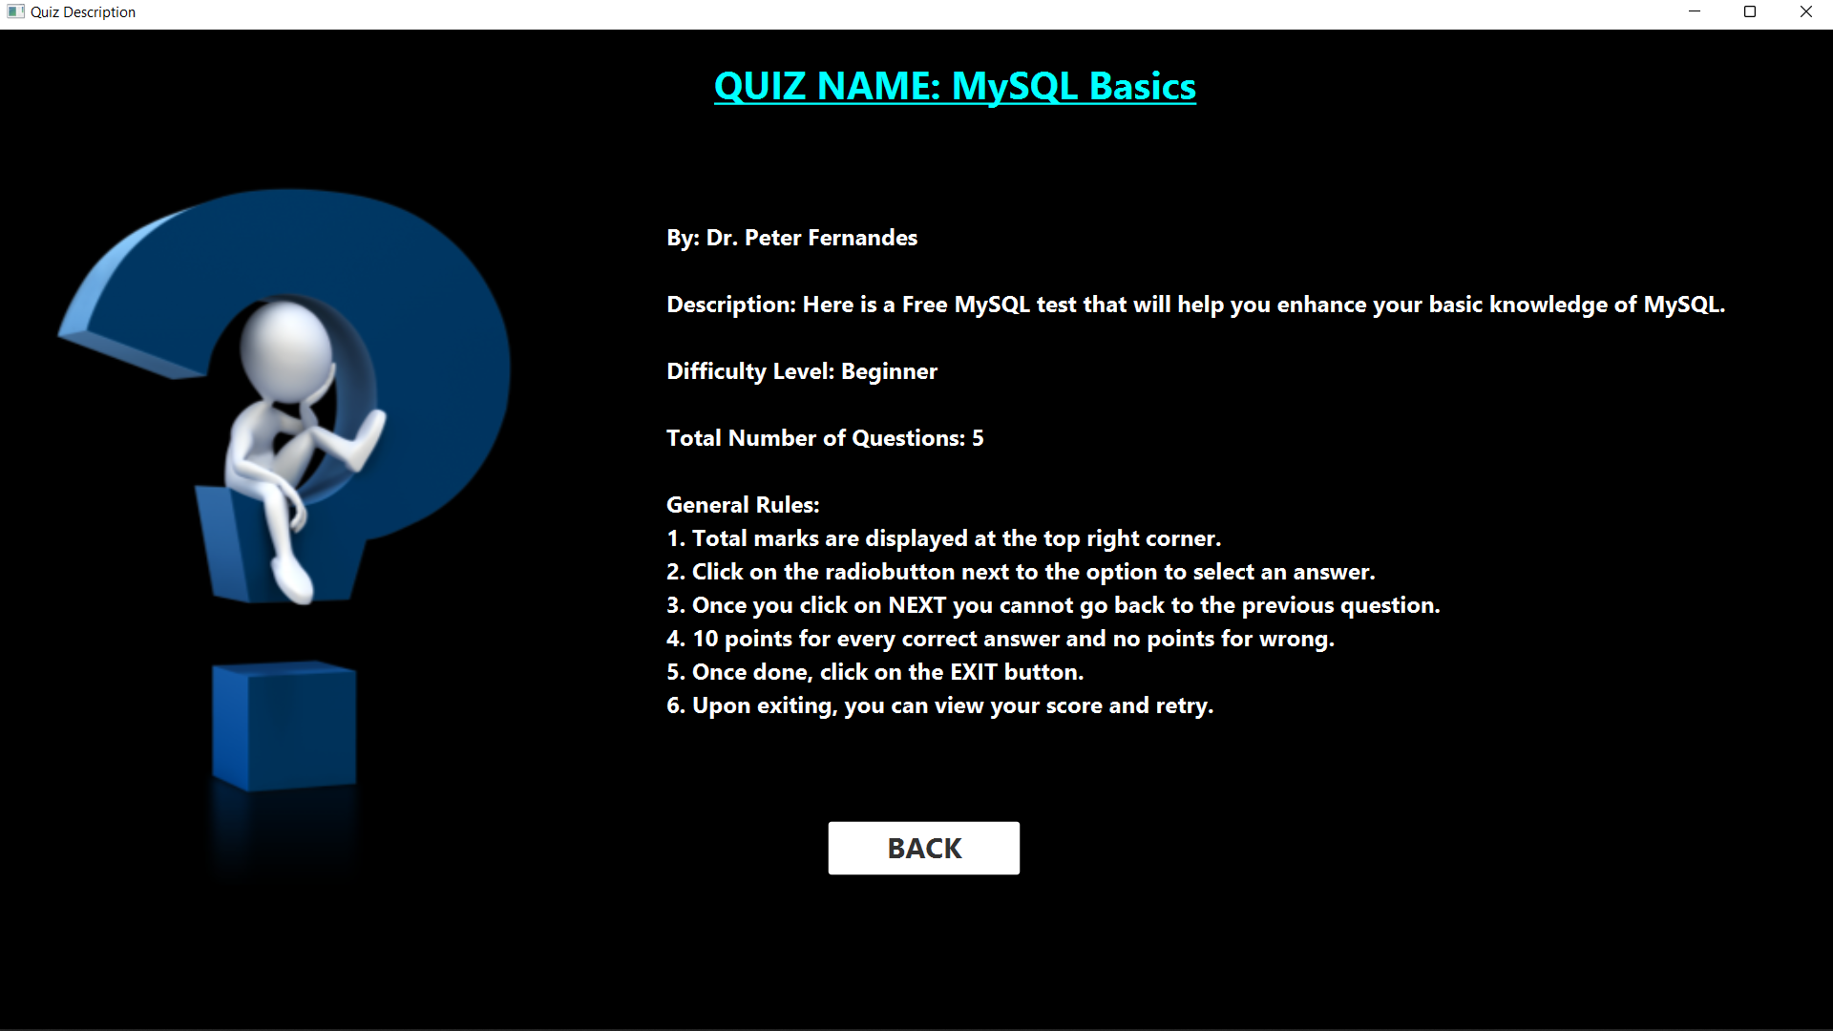

If you view a quiz created by you then as shown below you may view, edit or delete the quiz.

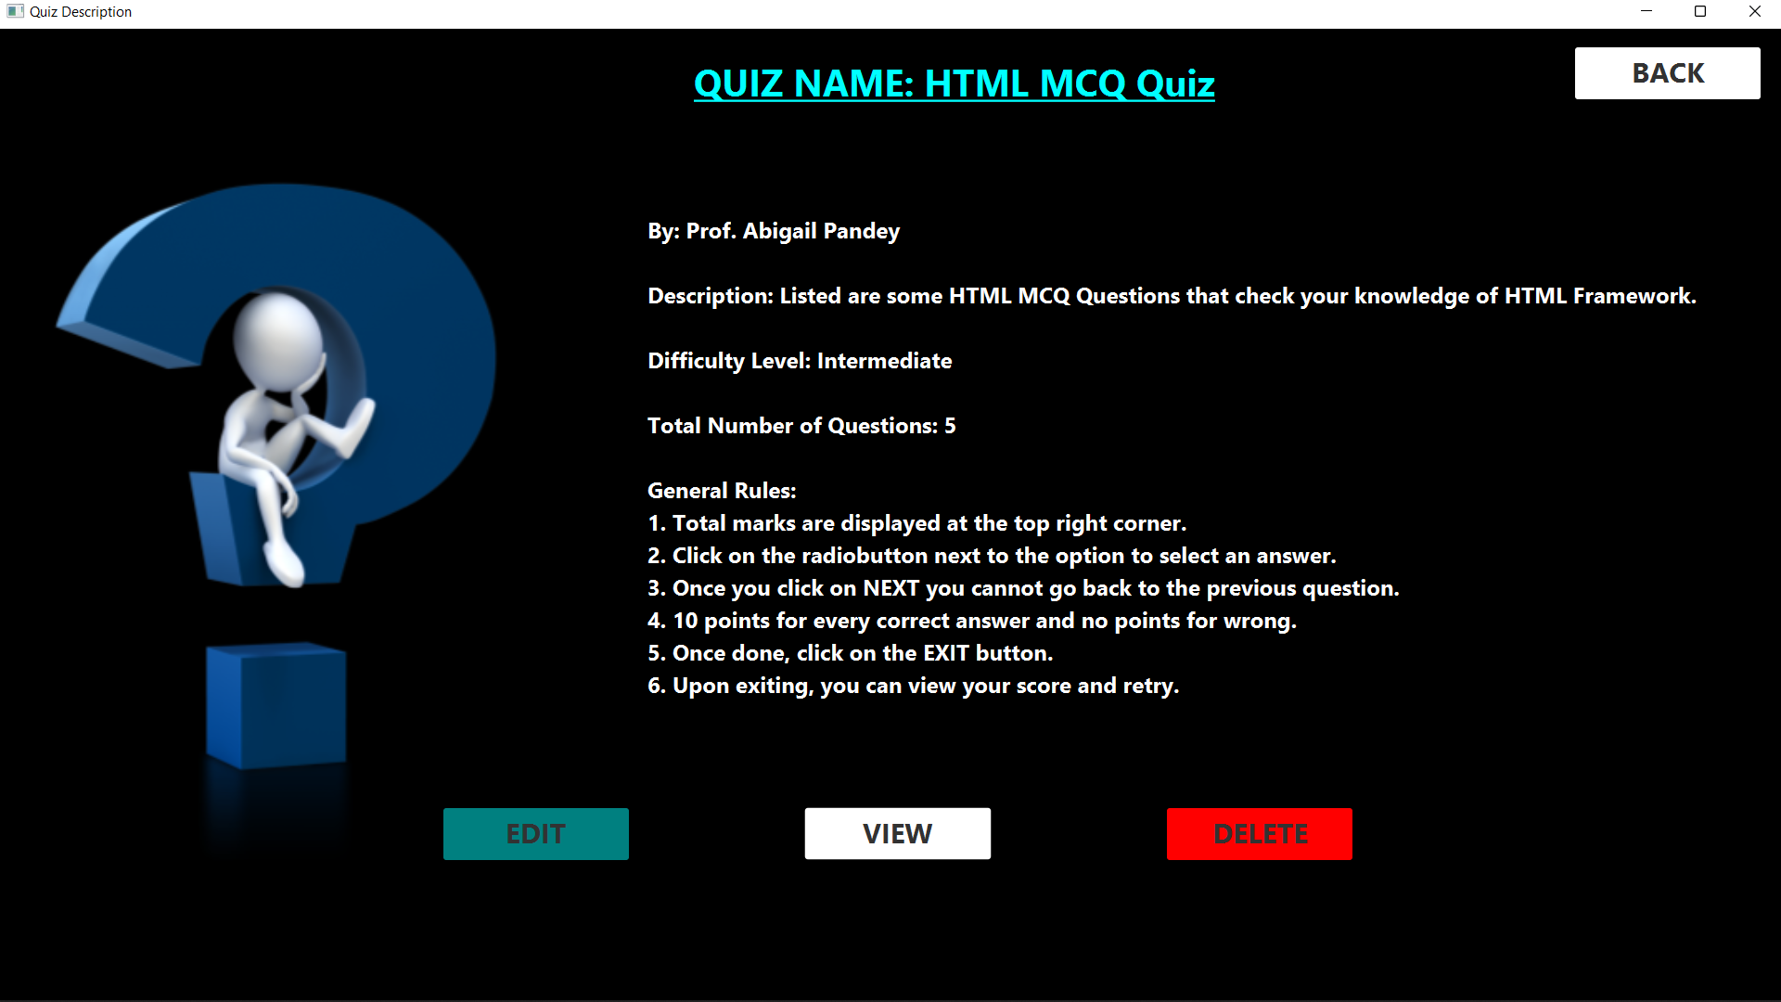

View quiz will show you the quiz that you have created as shown below.

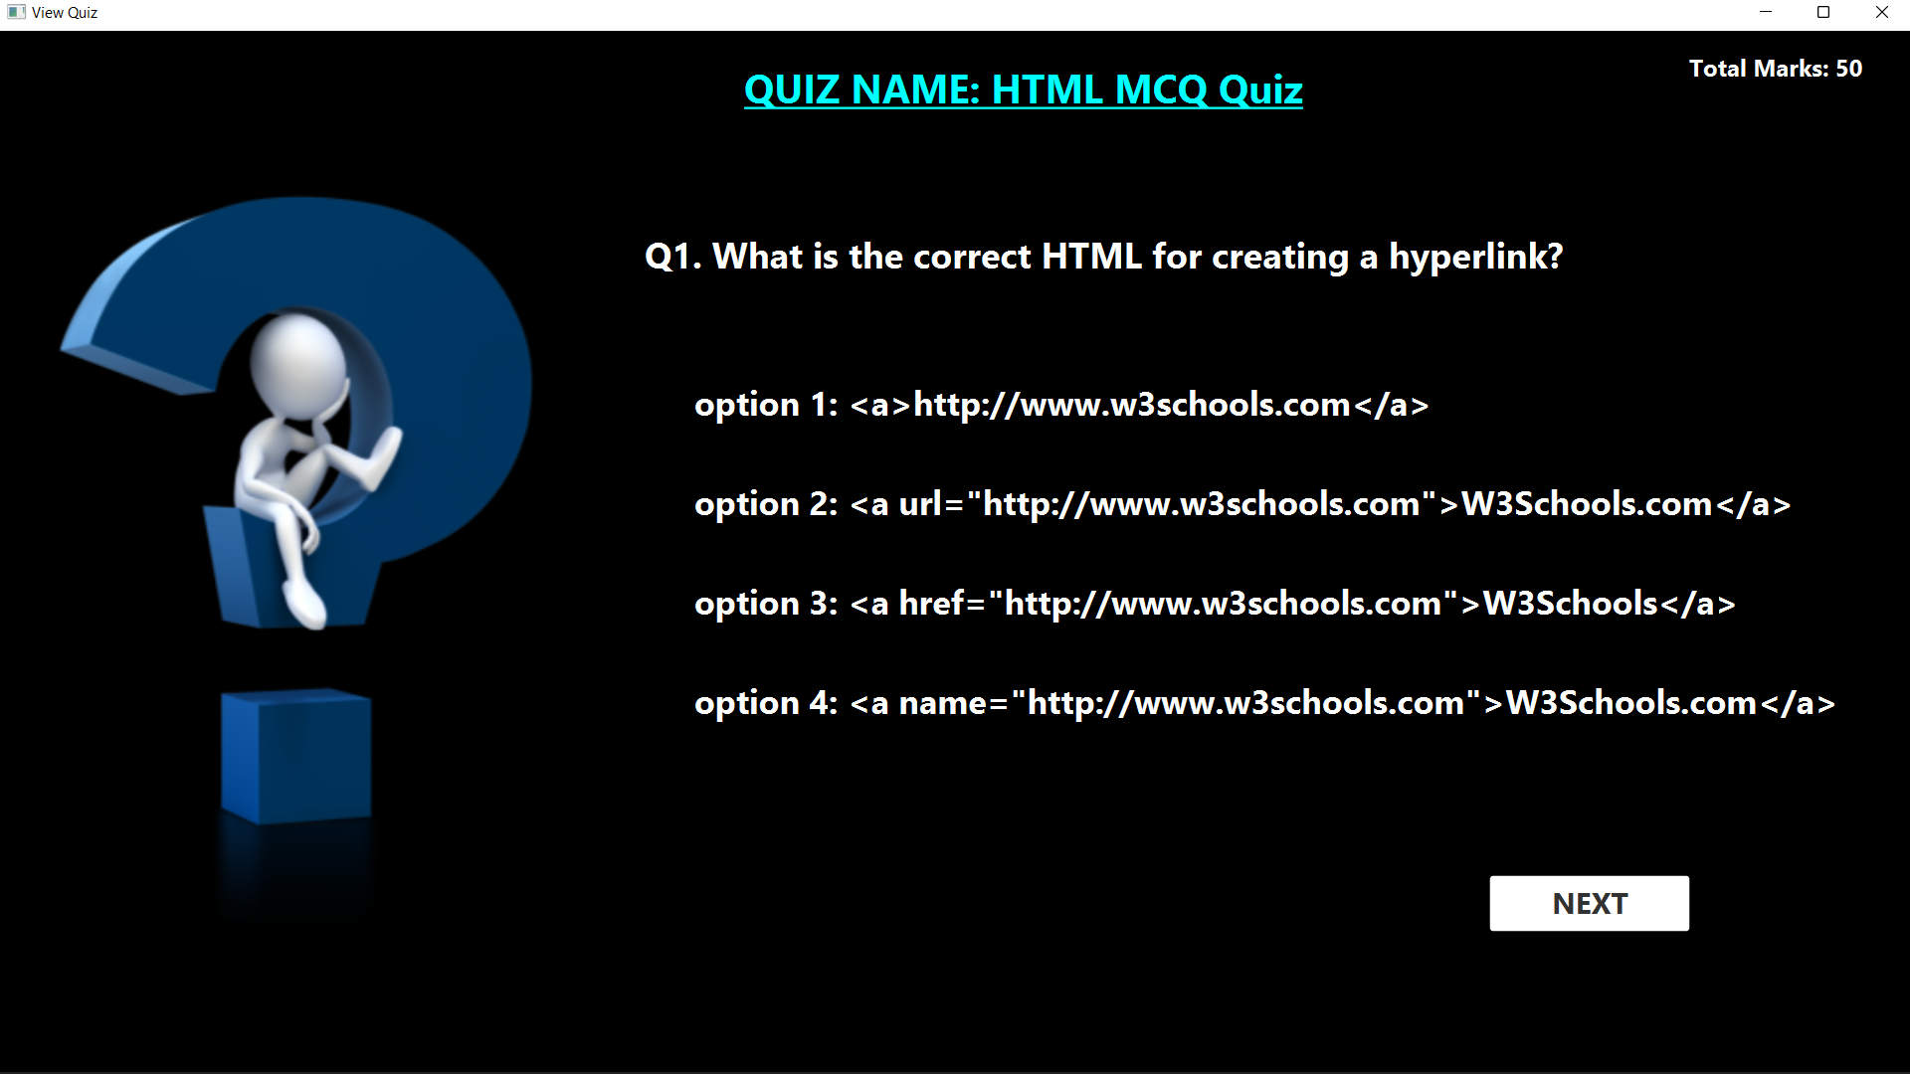

Edit will let you edit the quiz questions and options as shown below. Similarly, the Delete button will delete the quiz.

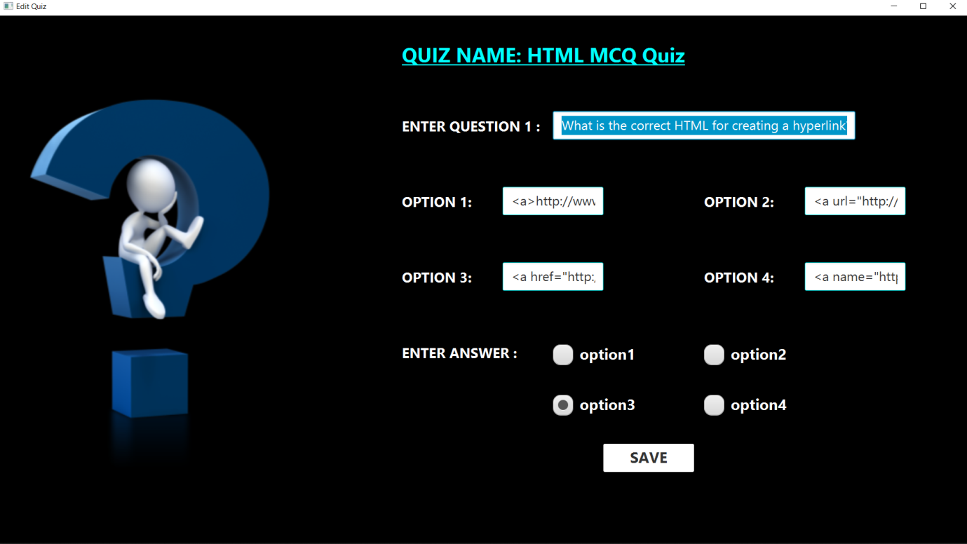

Moving on to the next section that is view results. As it can be seen from the image, this section will show you the results of students that have answered your quizzes.

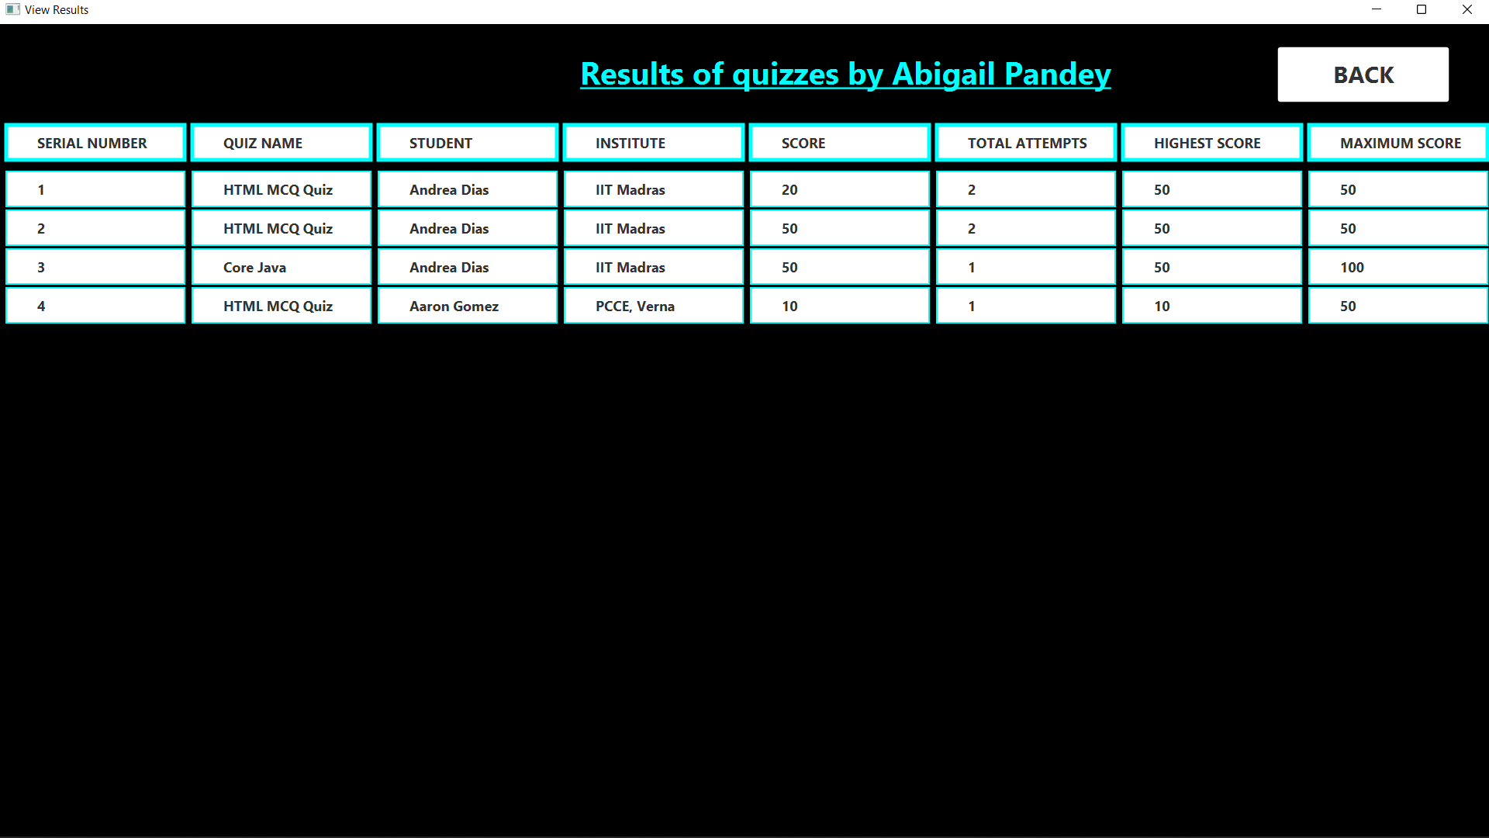

Next we move on to Student User.



To register as a Student enter the details shown below and click on submit. Click on login if you already have an account.

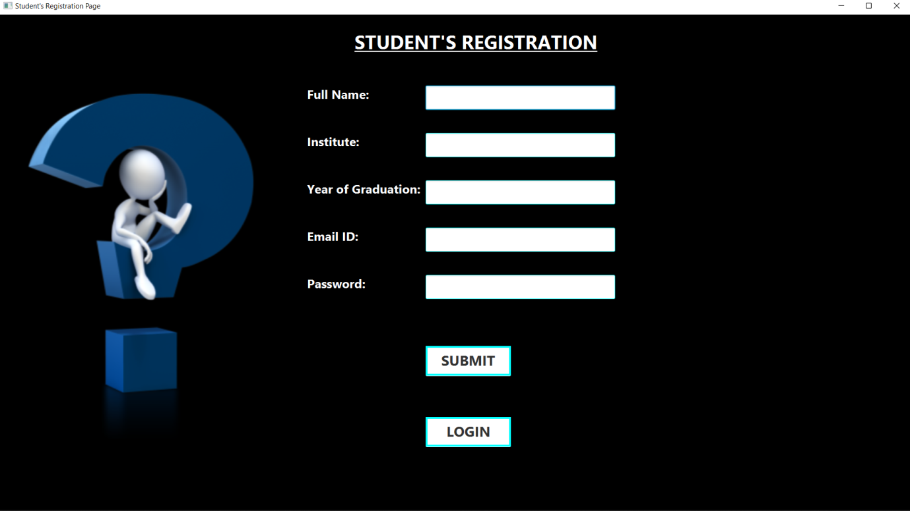

The reset password page will allow the student to reset his/her password.

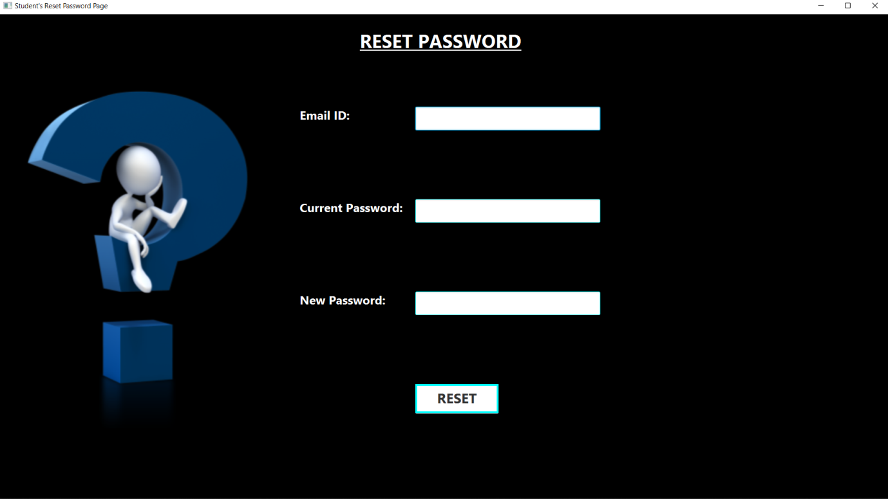

Once registered, login with your credentials.

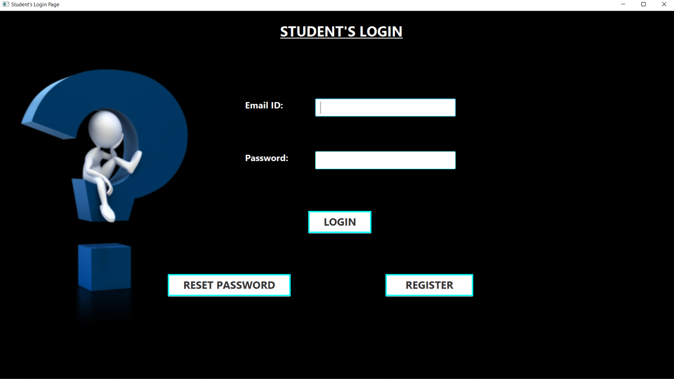

The Student’s Dashboard opens as follows. Let us have a look at each of these features.

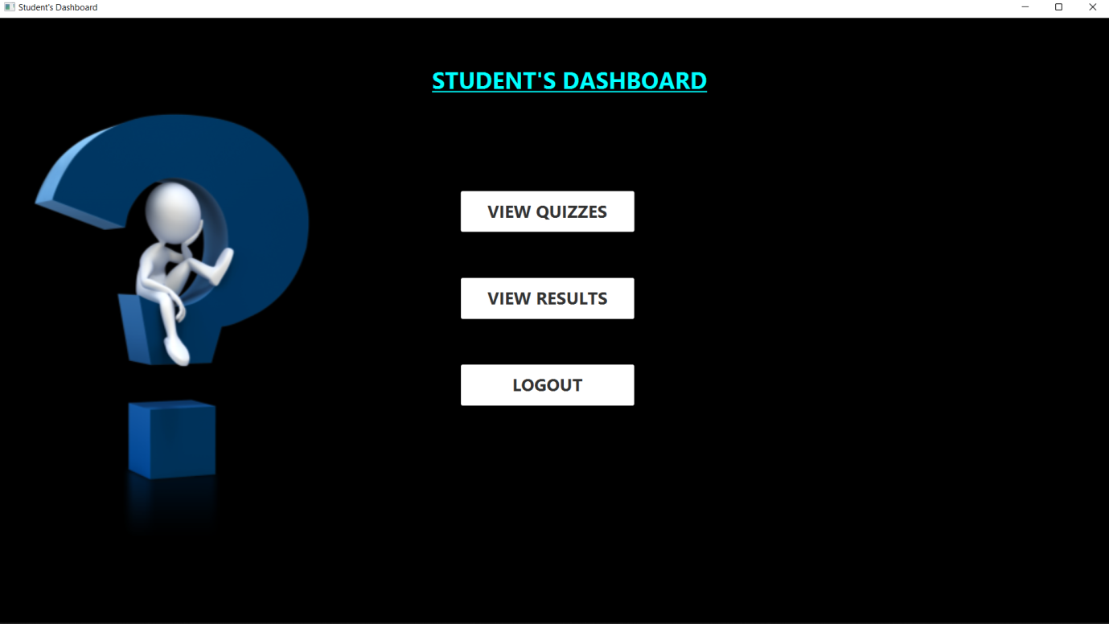

The view quizzes section displays a list of all quizzes as follows.

Clicking on a quiz will display the quiz details and will let the student answer the quiz.

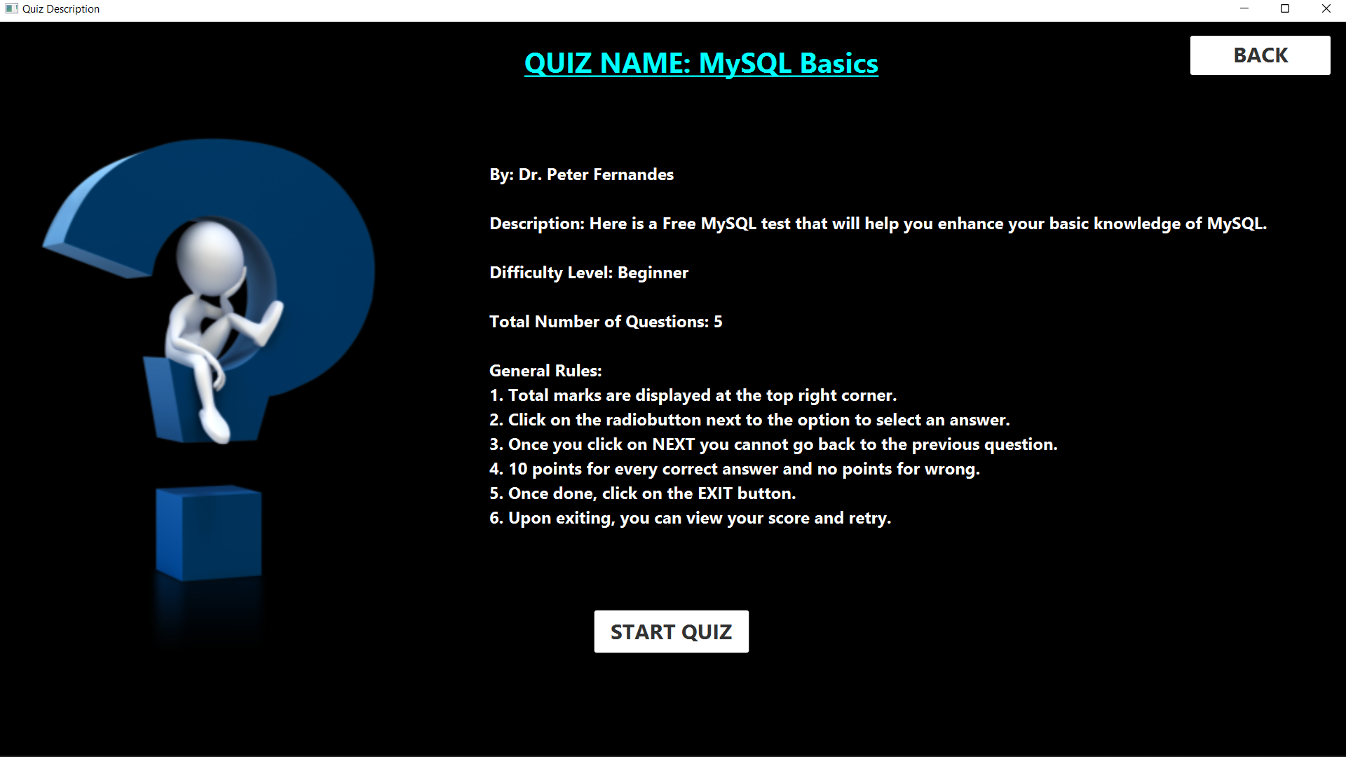

Once you click on start quiz, the quiz begins and you can answer the quiz as shown below.

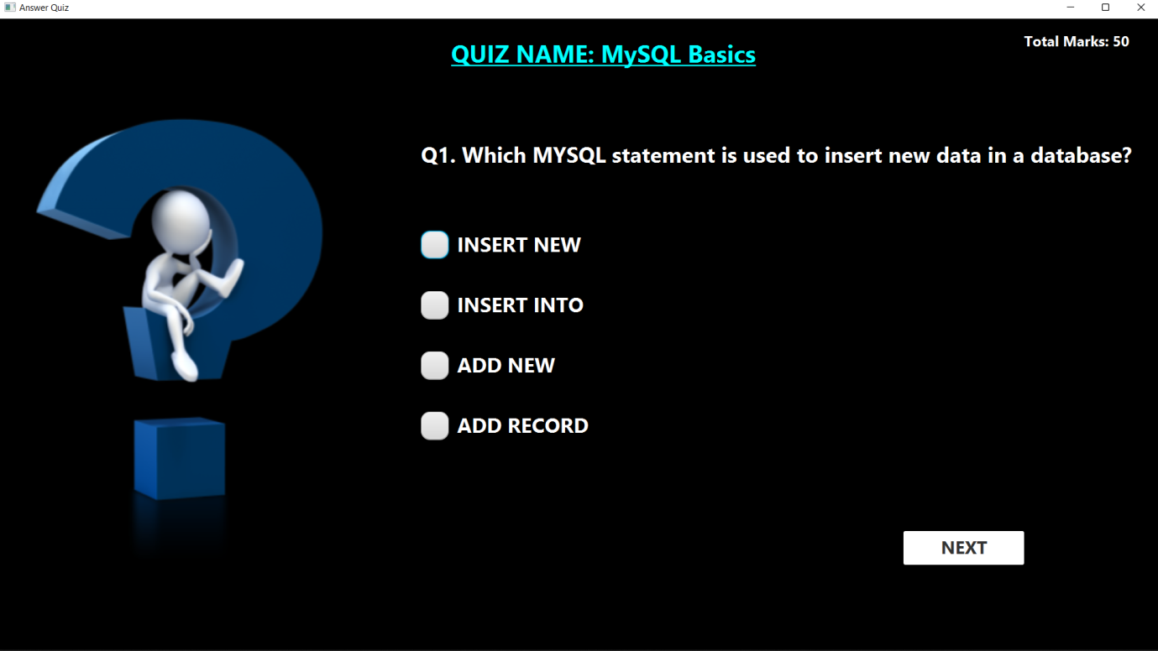

Once you submit your quiz score will be displayed as follows.

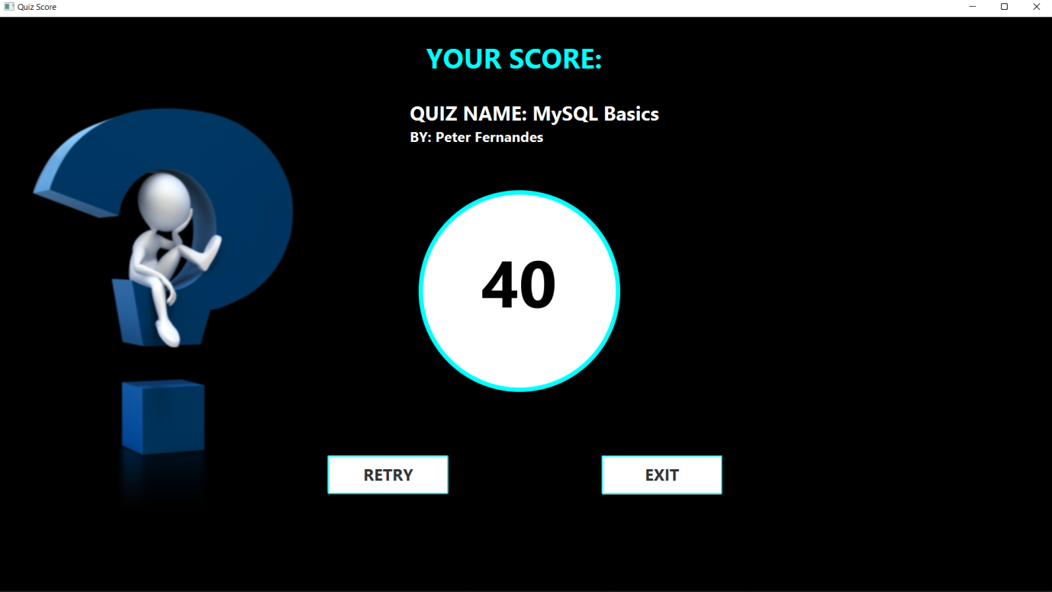

Next section is the View Results section. you can view the results of all the quizzes you’ve answered here.

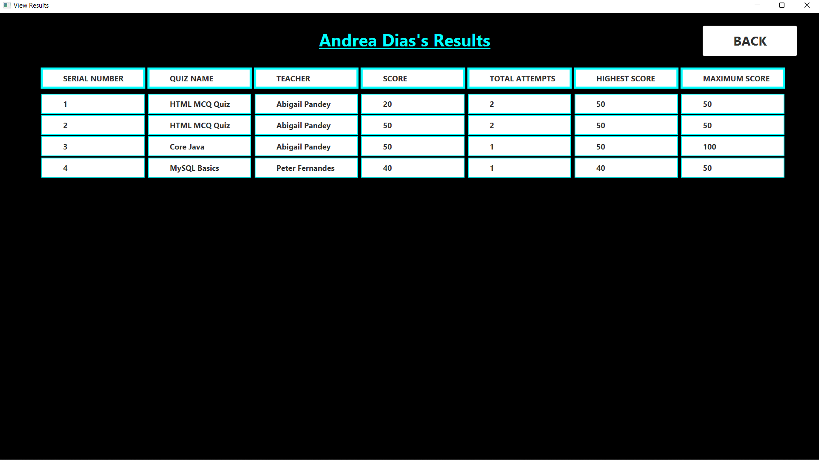

Click on the logout button once you are done.

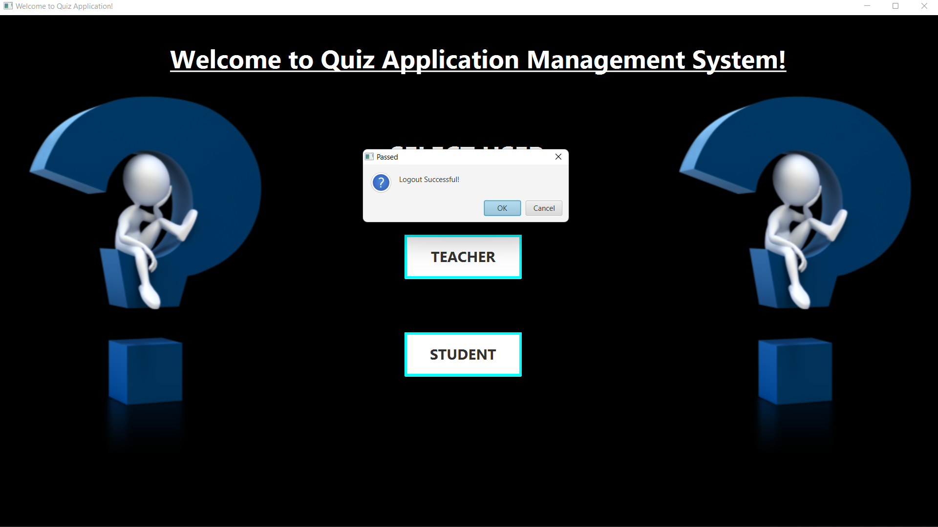

**Tables used in java_project Database:-**

teachers table – this table stores the credentials of all the registered teachers.

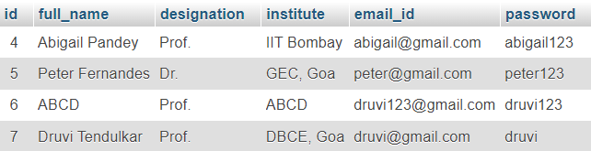

students table – This table stores the credentials of all the registered students.

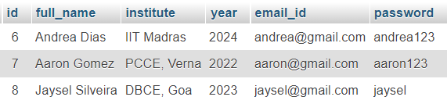

quiz table – this table stores all the quizzes along with all the details like questions, options and answers as shown below.

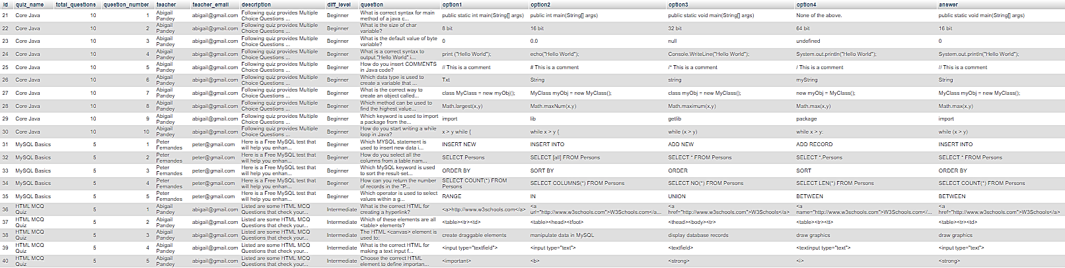

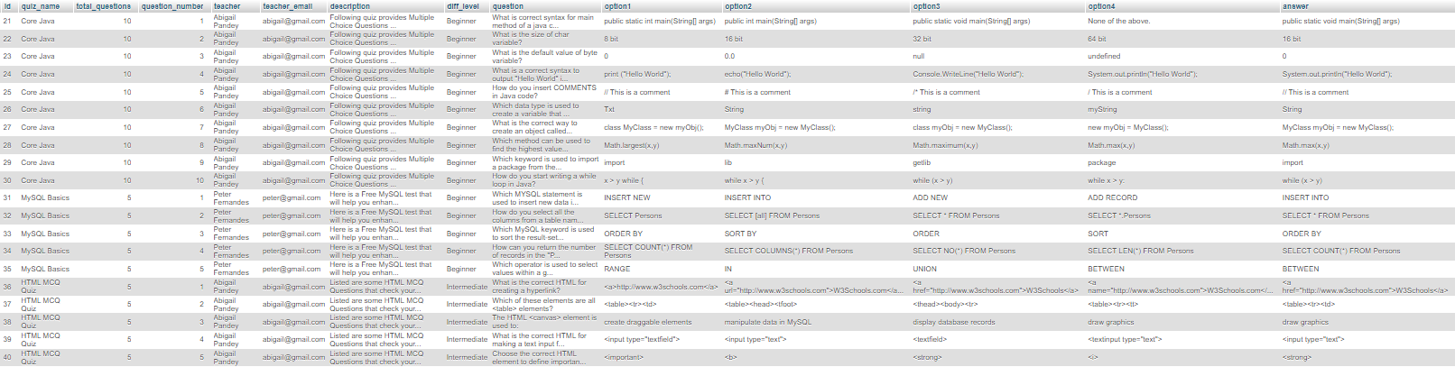

results table – stores the results of all the students who have attempted the quiz.

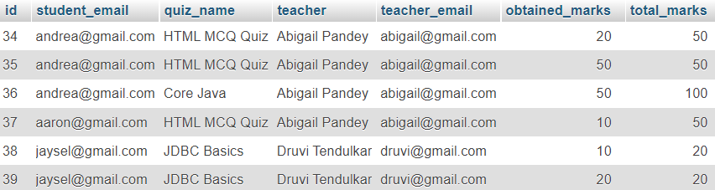

**Project ER Diagram:-**

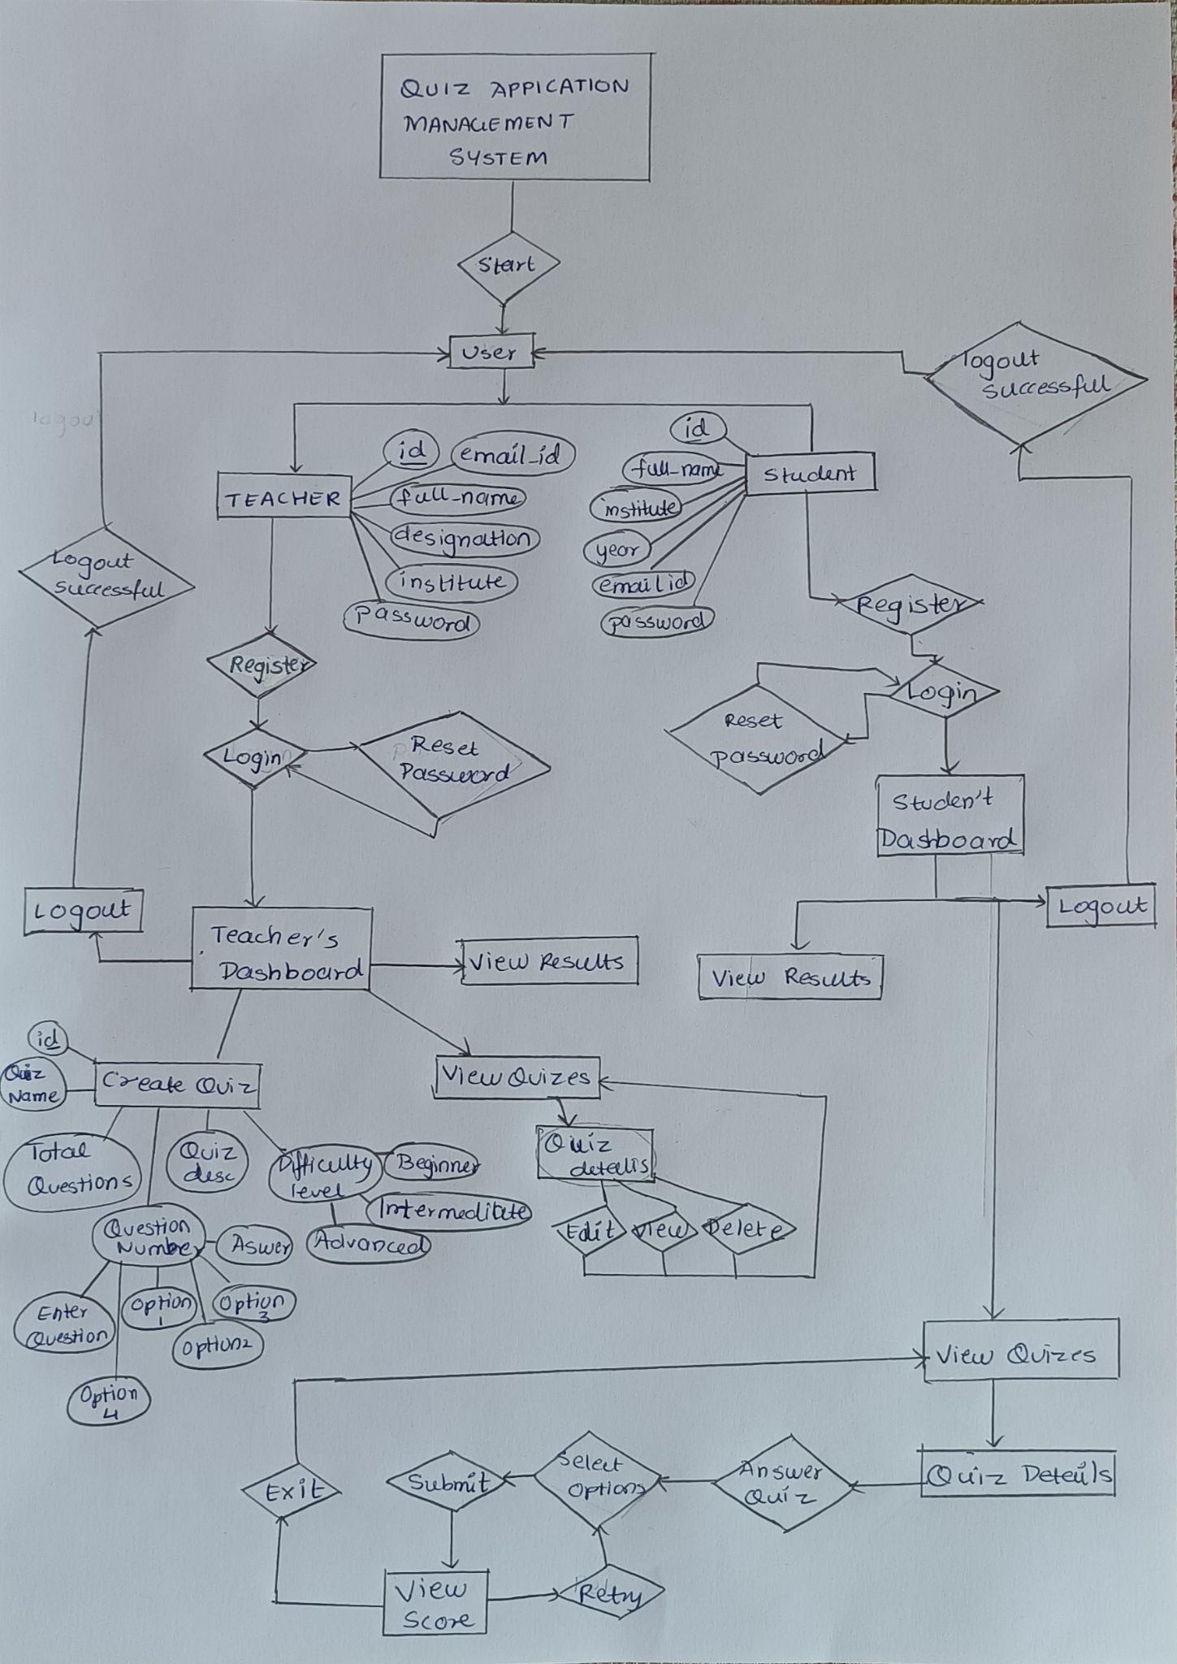

**CONCLUSION:-**

The mini-project on Quiz Application Management System using JavaFX API and JDBC was implemented successfully.